Alexander Baldree
06/05/26
1.3 Assignment
CSD430

GitHub Link:
https://github.com/Panda-Alex21687/CSD430

Java Version:
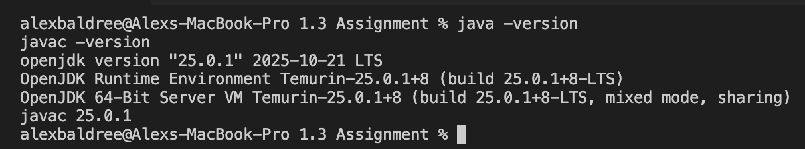
Apache Tomcat:
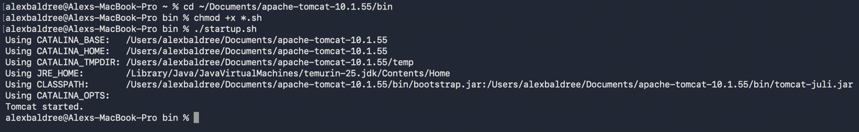
Started Tomcat:
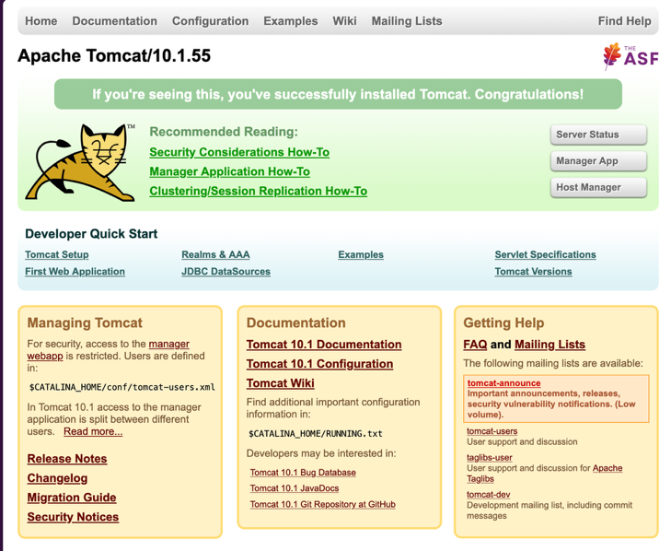
MyFirstJavaPage
